**Name: VYSHNAVI BABU S**

**Roll No: 55**

**Batch: B**

**Date:31-03-2022**

**NETWORKING & SYSTEM ADMINISTRATION LAB**

**Experiment No.: 1**

**Aim**

Familiarization of basic Linux commands.

**Procedure**

1. **cat -n /cat -b [filename] :** To display line numbers

**Syntax : $ cat -n filename**

**Output :**

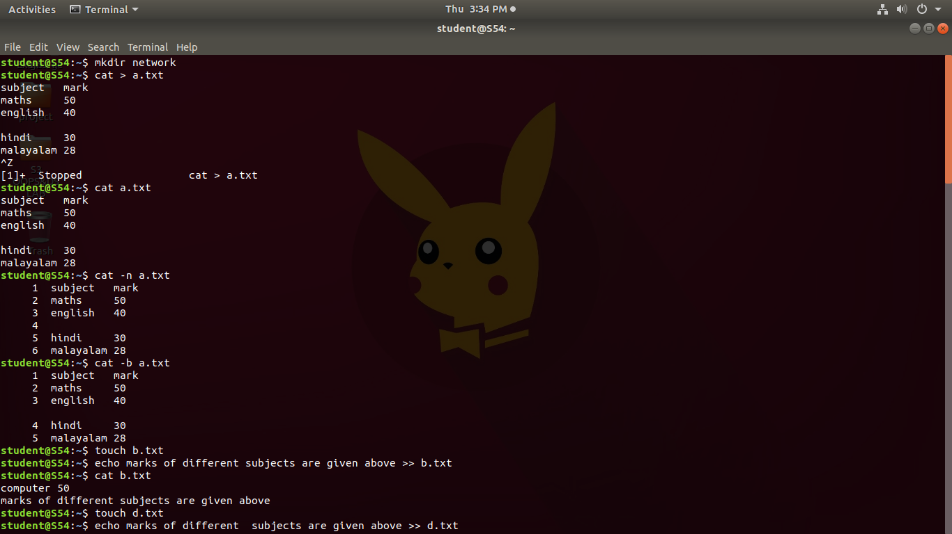

1. **touch filename :** To create an empty file.

**Syntax : $ cat filename**

**Output :**



1. **echo :** To add content to an empty file created using touch command.

**Syntax : $ echo [content] >> filename**

**Output :**



1. **head :** By default, it prints the first 10 lines of the specified files.

**Syntax : $ head [filename]**

**Output :**

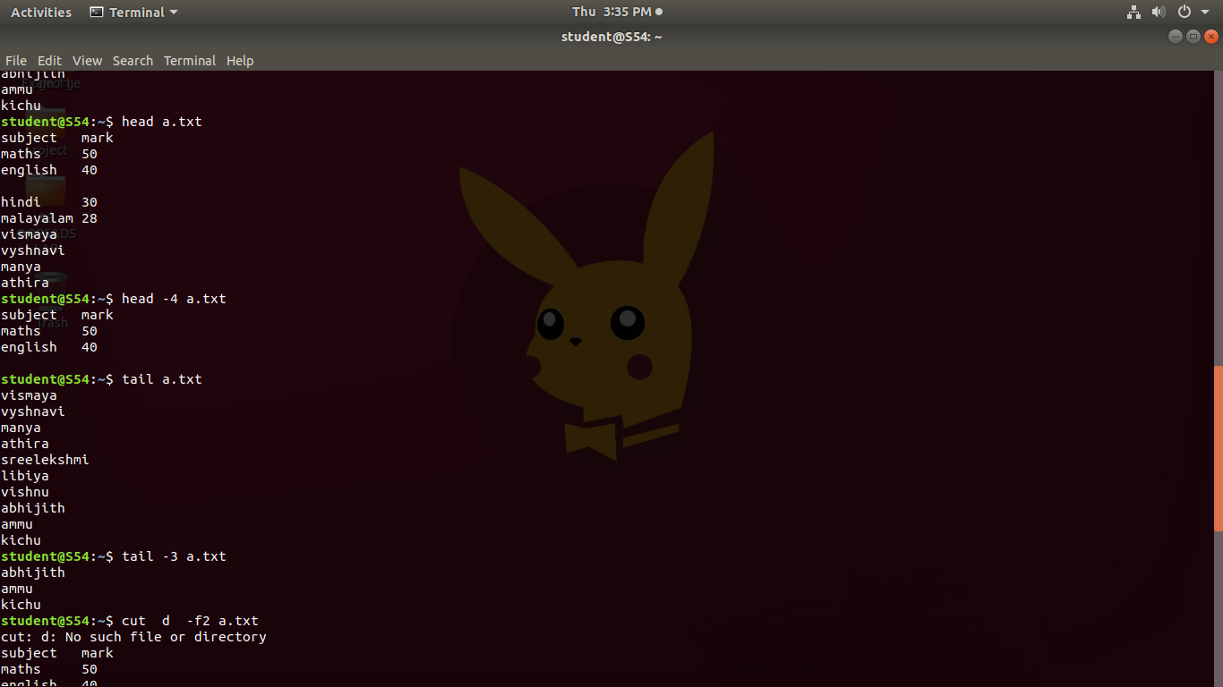

1. **head -4 [filename] :** To print first n lines of specified files.

**Syntax : $ head -n [filename]**

**Output :**



1. **tail :** By default, print last 10 lines of specified file.

**Syntax : $ tail [filename]**

**Output :**



1. **tail -3 [filename] :** To print last n lines of specified files.

**Synatx : $ tail -n [filename]**

**Output :**



1. **cut -d- -f2 [filename] :** It can be used to cut parts of a line by field.

**Syntax : $ cut -d "delimiter" -f (field number) file.txt**

**Output :**

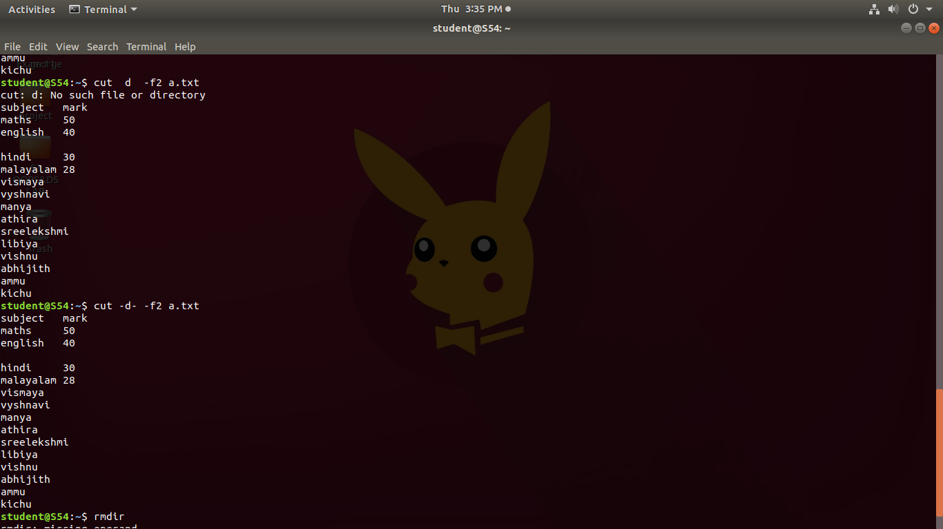

1. **rmdir :** Used to delete a directory if it is empty.

**Syntax : $ rmdir [directory name]**

**Output :**

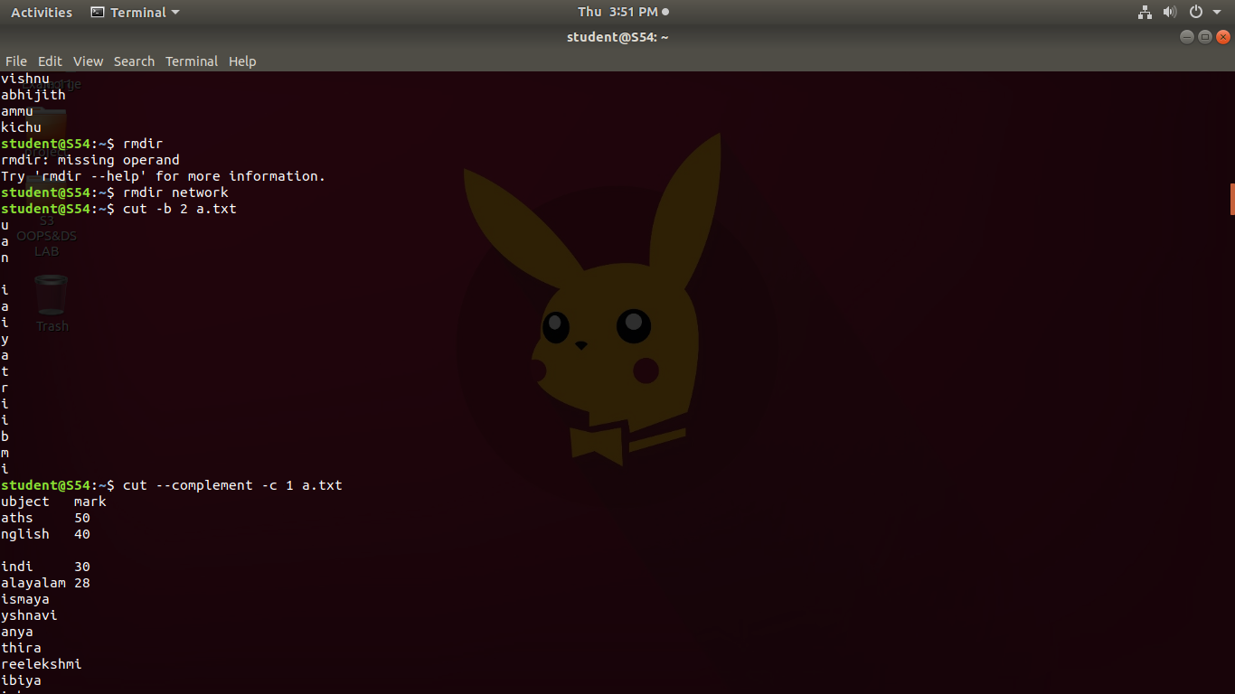

1. **cut -b 2 [filename] :** It can be used to cut parts of a line by **byte position(n).**

**Syntax : cut -b num [filename]**

**Output :**



1. **cut --complement -c 1 [filename] :** This option instructs cut to display all the fields, bytes or characters except the selected.

**Syntax : $ cut –complement -c num [filename]**

**Output :**

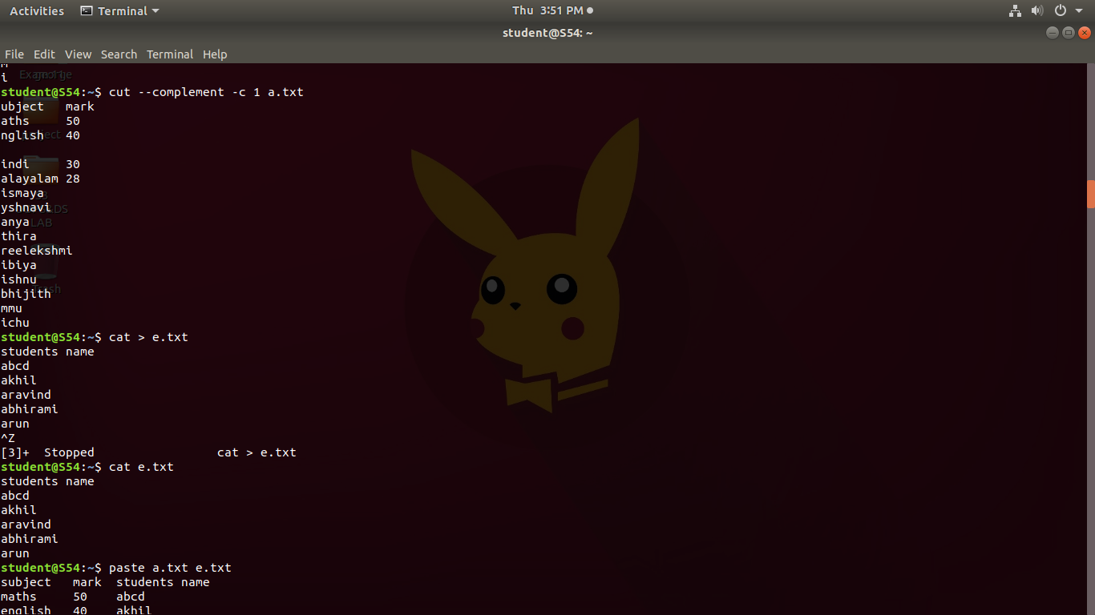

1. **paste marvel1 marvel2 :** To paste the content in one file to another file.

**Syntax : $ paste file1 file2**

**Output :**



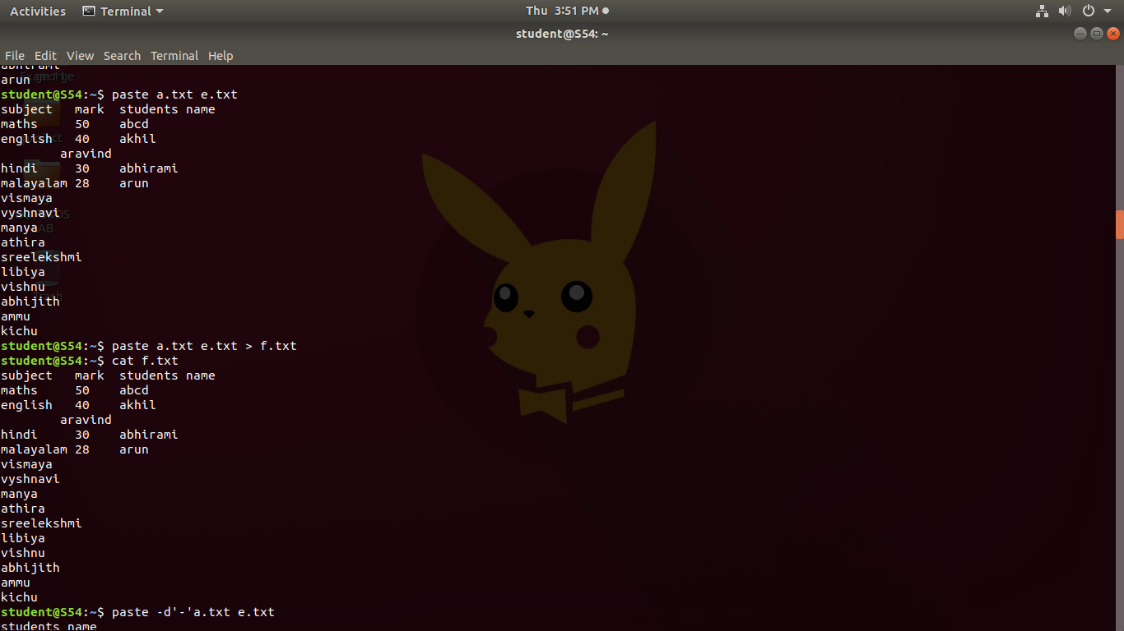

1. **paste marvel1 marvel2 > marvel3 :** To copy the contents of two given files to a third file.

**Syntax : $ paste file1 file2 > file3**

**Output :**



1. **paste -d ‘ - ’ marvel1 marvel :** The -d, -delimiters option allows you to specify a list of characters to be used as delimiters instead of the default TAB separator.

**Syntax : $ paste -d ‘ - ’ file1 file2**

**Output :**

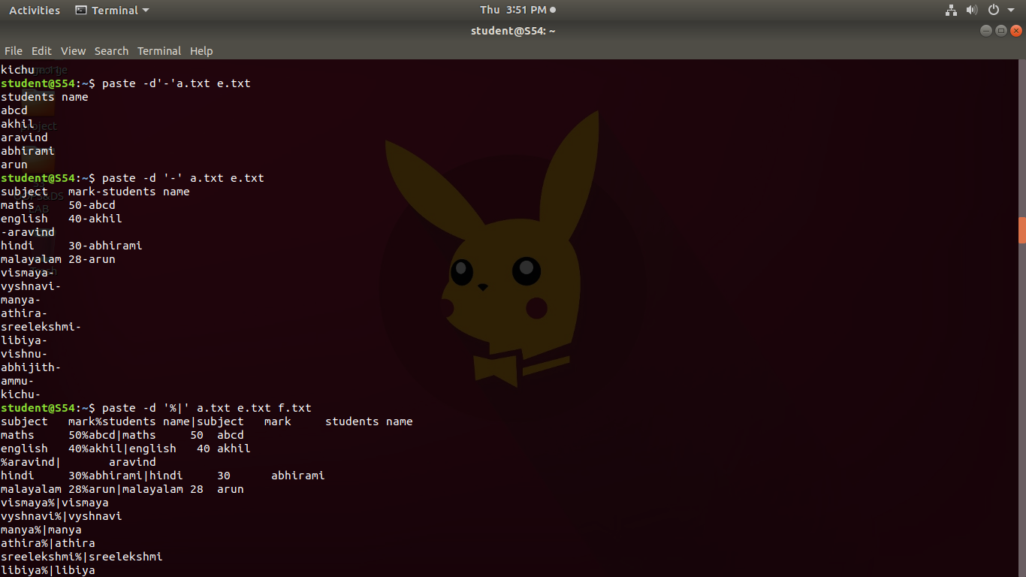

1. **paste -d ‘%|’ marvel1 marvel2 marvel1 :** Two delimiters are used. The lines from the first and the second file are separated with the first character from the delimiters list. The second and the third file lines are separated with the second delimiter.

**Syntax : $ paste -d ‘%|’ file1 file2 file1**

**Output :**

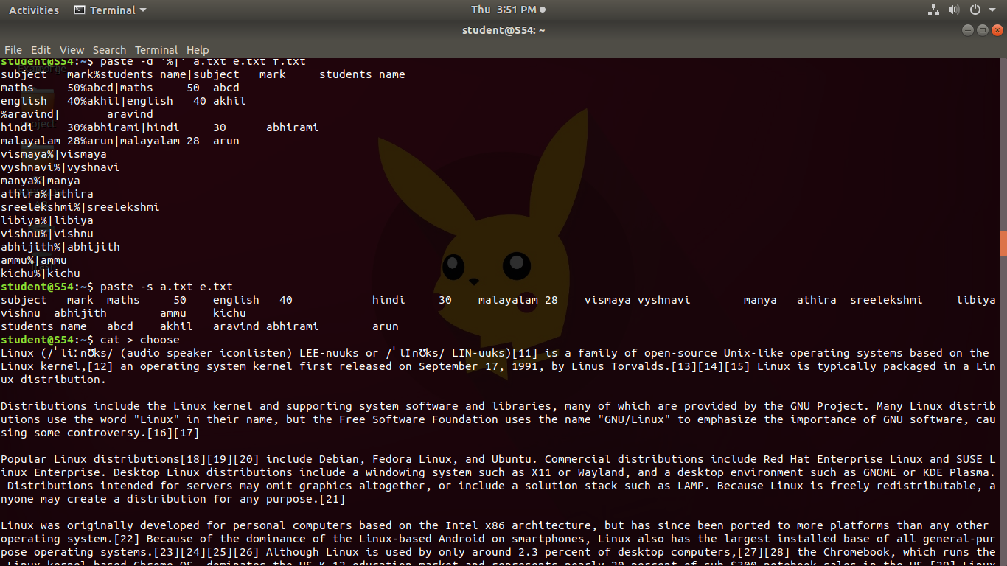

1. **paste -s marvel1 marvel2:** This command will merge all lines from the given file in separated lines.

**Syntax : $ paste -s file1 file2**

**Output :**



1. **more name :** The more command displays the first section of the file. By pressing the “ENTER” key, we can scroll line by line, all the way to the bottom of the file.

**Syntax : $ more filename**

**Output :**

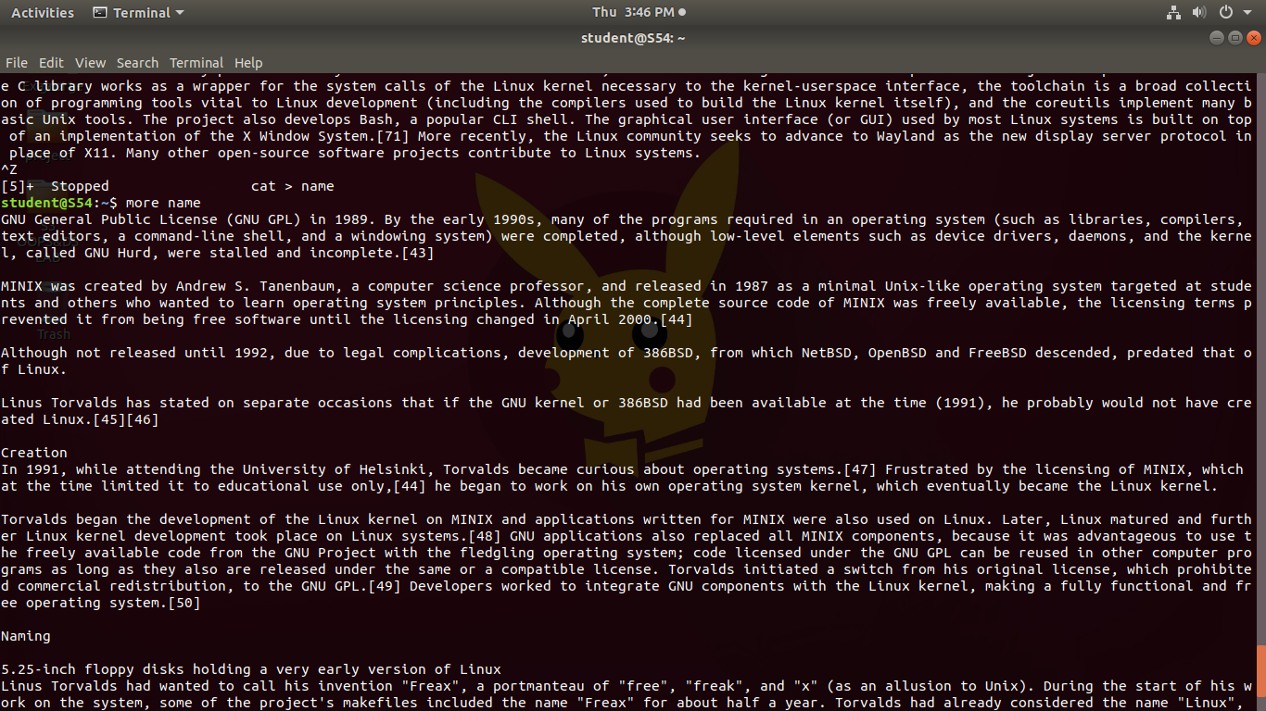

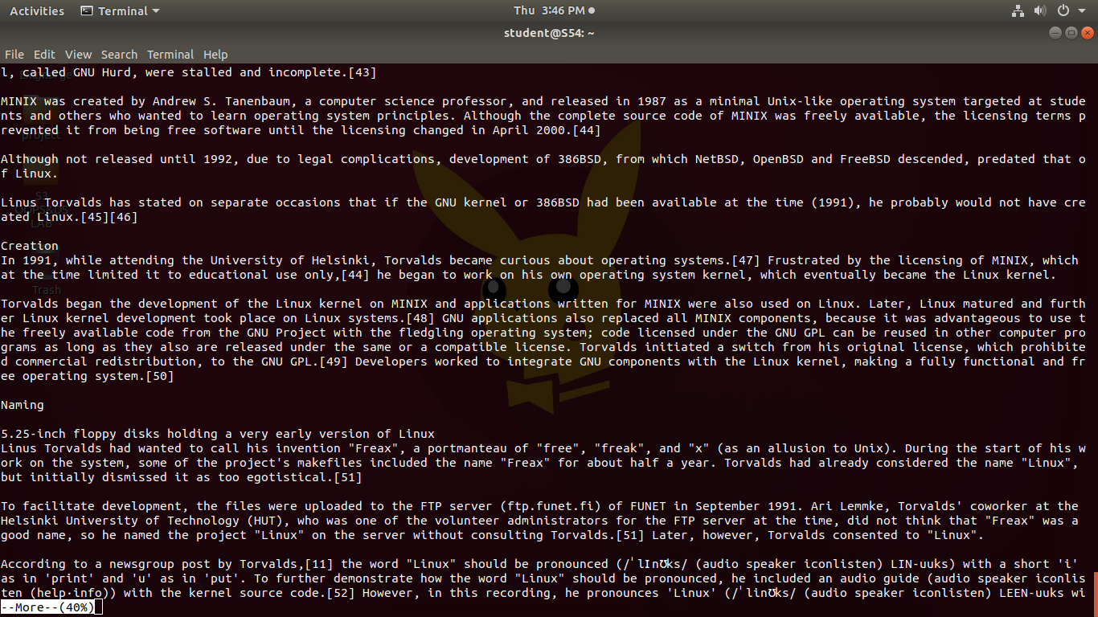

1. **more -3 name :** Used to type the number of lines(num) to display per screen.

**Syntax : $ more -num filename**

**Output :**

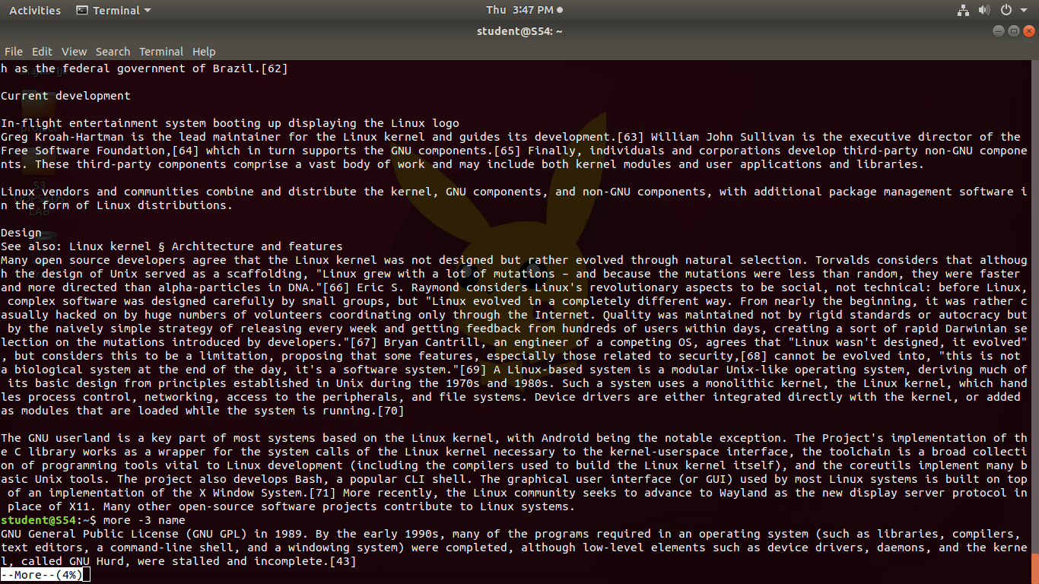

1. **more +3 name :** This option displays the text after the specified number of lines of the document.

**Syntax : $ more +num filename**

**Output :**

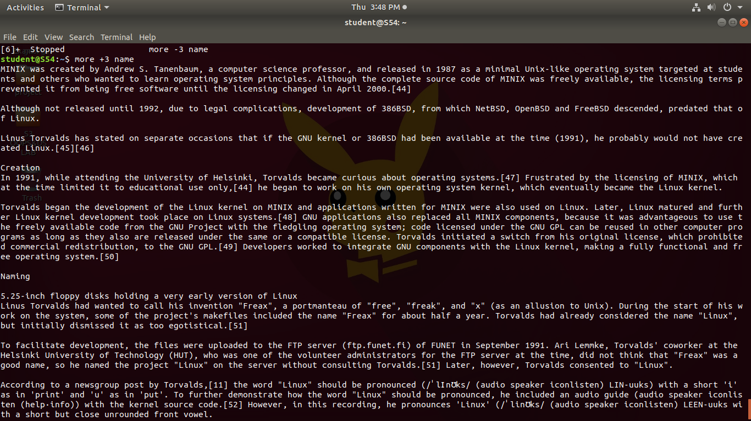

1. **more -s name :** This option squeezes multiple blank lines into one single blank line.

**Syntax : $ more -s filename**

**Output :**

